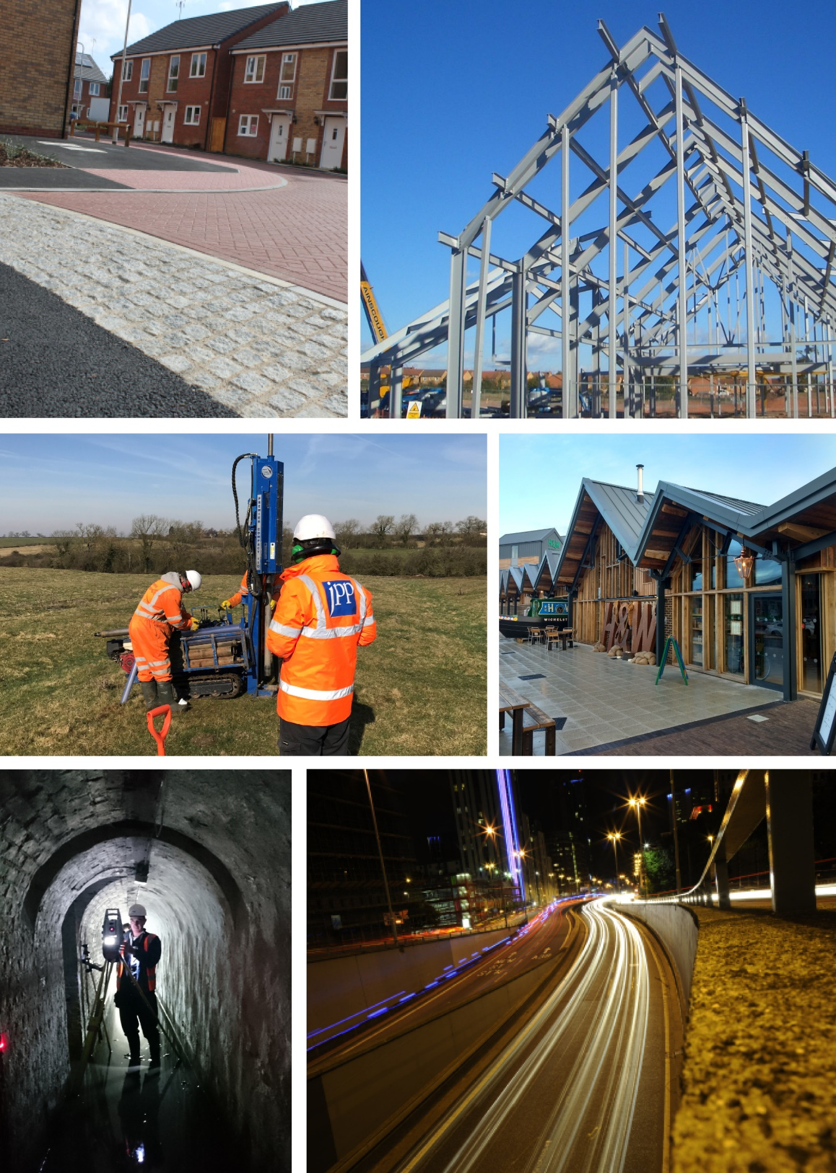

CLIENT

PROJECT LINE 1

PROJECT LINE 2

PROJECT LINE 3

Calculations

Revision :

R-C- - -

Calculations

JPP Consulting Ltd, Grand Union Works, Whilton Locks, Daventry, Northamptonshire, NN11 2NH
T: 01604 781811 |  | E: mail@jppuk.net | W: jppuk.net
Report Reference  Date | R-C- - -  Revision :
Report Originators
Prepared by
 |  | Name
 |  | Position
 |  | Email address
Reviewed by
 |  | Name
 |  | Position
 |  | Email address

Revision | Date | Description | Prepared | Reviewed
0

Contents
1.0 Design Notes 1
2.0 Main Heading - Heading 1 6
2.1 Sub Heading - Heading 2 6
2.1.1 Sub sub heading - Heading 3 6

Appendices
Appendix A A
Appendix details A

Design Notes

Dimensions used in the following calculations are for design only and shall not be used for constructional purposes.

Any construction details and dimensions indicated in the following calculations shall not be varied unless they are substantiated by calculation, and approved in writing by the Engineer.

The British Standards and Codes of Practice highlighted below have been used in the preparation of these calculations - all constructional details must be in accordance with all relevant clauses contained in these same standards or associated standards.

Design Codes
Code | Title | Used
British Standards (Eurocodes)
Eurocode 0 Basis of Structural Design
BS EN 1990:2002+A1:2005 and UK NA | Basis of structural design
Eurocode 1 Actions on Structures
BS EN 1991-1
BS EN 1991-1-1:2002 and UK NA | General actions - Densities, self-weight, imposed loads for buildings
PD 6688-1-1:2011 | Recommendations for the design of structures to BS EN 1991-1-1
BS EN 1991-1-2:2002 and UK NA | General actions - Actions on structures exposed to fire
PD 6688-1-2:2007 | Background paper to the UK National Annex to BS EN 1991-1-2
BS EN 1991-1-3:2003 and UK NA | General actions - Snow loads
BS EN 1991-1-4:2005 and UK NA | General actions - Wind actions
PD 6688-1-4:2009 | Background information to the National Annex to BS EN 1991-1-4 and additional guidance
BS EN 1991-1-5:2003 and UK NA | General actions - Thermal actions
BS EN 1991-1-6:2005 and UK NA | General actions - Actions during execution
BS EN 1991-1-7:2006 and UK NA | General actions - Accidental actions
PD 6688-1-7:2009 | Recommendations for the design of structures to BS EN 1991-1-7
Eurocode 2 Design of concrete structures
BS EN 1992-1
BS EN 1992-1-1:2004 and UK NA | General rules and rules for buildings
BS EN 1992-1-2:2004 and UK NA | General rules. Structural fire design
PD 6687-1:2010 | Background paper to the UK National Annexes to BS EN 1992-1 and BS EN 1992-3
Eurocode 3 Design of steel structures
BS EN 1993-1
BS EN 1993-1-1:2005 and UK NA | General rules and rules for buildings
BS EN 1993-1-2:2005 and UK NA | General rules - Structural fire design
BS EN 1993-1-3:2006 and UK NA | General rules - Supplementary rules for cold-formed members and sheeting
BS EN 1993-1-5:2007 and UK NA | Piling
BS EN 1993-1-8:2005 and UK NA | Design of joints
Eurocode 5 Design of timber structures
BS EN 1995-1
BS EN 1995-1-1:2004+A2:2014 and UK NA | General - Common rules and rules for buildings
BS EN 1995-1-2:2004 and UK NA | General - Structural fire design
Eurocode 6 Design of masonry structures
BS EN 1996-1
BS EN 1996-1-1:2005 and UK NA | General rules for reinforced and unreinforced masonry structures
PD 6697:2010 | Recommendation for the design of masonry structures to BS EN 1996-1-1 and BS EN 1996-2
BS EN 1996-1-2:2005 and UK NA | Structural fire design
BS EN 1996-2
BS EN 1996-2:2006 and UK NA | Design considerations, selection of materials and execution of masonry
PD 6697:2010 | Recommendations for the design of masonry structures to BS EN 1996-1-1 and BS EN 1996-2
BS EN 1996-3
BS EN 1996-3:2006 and UK NA | Simplified calculation methods for unreinforced masonry structures
Eurocode 7 Geotechnical design
BS EN 1997-1
BS EN 1997-1:2004 and UK NA | General rules
PD 6694-1:2011 | Recommendations for the design of structures subject to traffic loading to BS EN 1997-1
British Standards (Non-Eurocodes)
Loadings
BS 6399:Part 1:1996 | Loadings for Buildings  Code of Practice for Dead and Imposed Loads
BS 6399:Part 2:1997 | Loadings for Buildings  Code of Practice for Wind Loads
BS 6399:Part 3:1988 | Loadings for Buildings  Code of Practice for Imposed Roof Loads
CP3:Chapter V:Part 2:1972 | Loading  Wind Loads
BS 648:1964 | Schedule of weights of building materials
Concrete
BS 8110:Part 1:1997 | Structural Use of Concrete  Code of Practice for Design and Construction
BS 8110:Part 3:1985 | Design Charts for Singly Reinforced Beams, Doubly Reinforced Beams and Rectangular Columns
BS 8007:1987 | Code of Practice for Design of Concrete Structures for Retaining  Aqueous Liquids
Foundations and Retaining Structures
BS 8004:1986 | Code of Practice for Foundations
BS 8004:2015 | Code of Practice for Foundations
CP 2012:Part 1:1974 | Code of Practice for Foundations for Machinery  Foundations for Reciprocating Machinery
BS 8002:1994 | Code of Practice for Earth Retaining Structures
BS 8002:2015 | Code of Practice for Earth Retaining Structures
Timber
BS 5268:Part 2:2002 | Structural Use of Timber  Code of Practice for Permissible Stress Design, Materials and Workmanship
BS 5268:Part 3:1998 | Structural Use of Timber  Code of Practice for trussed rafter roofs
Masonry
BS 5628:Part 1:2005 | Code of Practice for the Use of Masonry  Structural Use of Unreinforced Masonry
BS 5628:Part 2:2005 | Code of Practice for the Use of Masonry  Structural Use of Reinforced and Prestressed Masonry
BS 5628:Part 3:2005 | Code of Practice for the Use of Masonry  Materials and Components, Design and Workmanship
Industrial Floor Slabs
Concrete Industrial Ground Floors;
Concrete Society Technical Report 34 (4th Edition)
Concrete Ground Floors;
Their Design, Construction and Finish
Design of Floors on the Ground;
C & CA Technical Report 550
The Design of Ground Supported Concrete Industrial Floor Slabs;
BCA Tech Note 11
Drainage
BS EN 752:2008 | Drain and sewer systems outside buildings
BS EN 12056:Part 2:2000 | Gravity drainage systems inside buildings  Sanitary pipework, layout and calculation
BRE Digest 365 | Soakaway design
 | Table for the Hydraulic Design of Storm Drains, Sewers and Pipelines
 | Water Authorities Association; Sewers for Adoption; Design and Construction (6th Edition)
Steelwork
BS 5950:Part 1:2000 | Structural Use of Steelwork in Buildings: Codes of Practice for Design in Simple and Continuous Construction; Hot Rolled Sections
BS 5950:Part 3 | Structural Use of Steelwork in Buildings  Design in Composite Construction
BS 5950:Part 3:S 3.1; 1990 | Structural Use of Steelwork in Buildings  Code of Practice for Design of Simple and Continuous Composite Beams
BS 5950:Part 5:1987 | Structural Use of Steelwork in Buildings  Code of Practice for Design of Cold Formed Sections
BS 5950:Part 8:1990 | Structural Use of Steelwork in Buildings  Code of Practice for Fire Resistant Design
BS 2853:1957 | Specification for the design and testing of steel overhead runway beams
Temporary Works
BS 5975:2008 | Code of practice for temporary works procedures and the permissible stress design of falsework

The software highlighted below have been used in the preparation of these calculations in conjunction with the associated standards.
Design Software
Program | Version | Used
CADS A3DMAX | 4.14
CADS Masonry Wall Panel Designer MAX | 2.03
CADS RC Beam Designer | 4.05
CADS RC Column Designer | 2.04
CADS RC Pad Base Designer | 3.04
CADS RC Pile Cap Designer | 2.05
CADS SMART Engineer | 6.41
CADS SMART Portal 2D | 4.20
CADS SW Member Designer | 3.62
CADS SW Moment Connections | 1.74
Nemetschek SCIA Engineer | 2014
Hilti PROFIS Anchor | 2.5.0

Appendix A

Appendix details

